Pure Aloha

1. Aloha is a random access protocol
2. It was actually designed for WLAN but it is also applicable for shared medium
3. In this, multiple stations can transmit data at the same time and can hence lead to collision and data being garbled.
4. Collision:
   1. 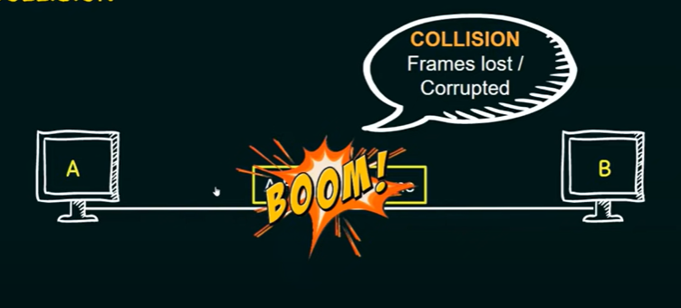
5. Types of aloha:
   1. Pure aloha
   2. Slotted Aloha

Pure aloha

1. Pure aloha allows stations to transmit whenever they have data to be snet.
2. When a station sends data it waits for an acknowledgement.
3. If the ack does not come within the allocated time then the station waits for a random amount of time called back-off time(Tb) and re-sends the data.
4. Since different stations wait for different amounts of time, the probability of further collision decreases.
5. The throughput of pure aloha is maximized when frames are of uniform length.
6. Whenever two frames try to occult the channel at the same time, there will be a collision and both will be garbled.
7. If the first bit of a new frame overlaps with just the last bit of a frame almost finished, both frames will be totally destroyed and both will have to be retransmitted later.
8. Vulnerable Time = 2\*Tfr
9. 